S.A.F.E. AREA Manual

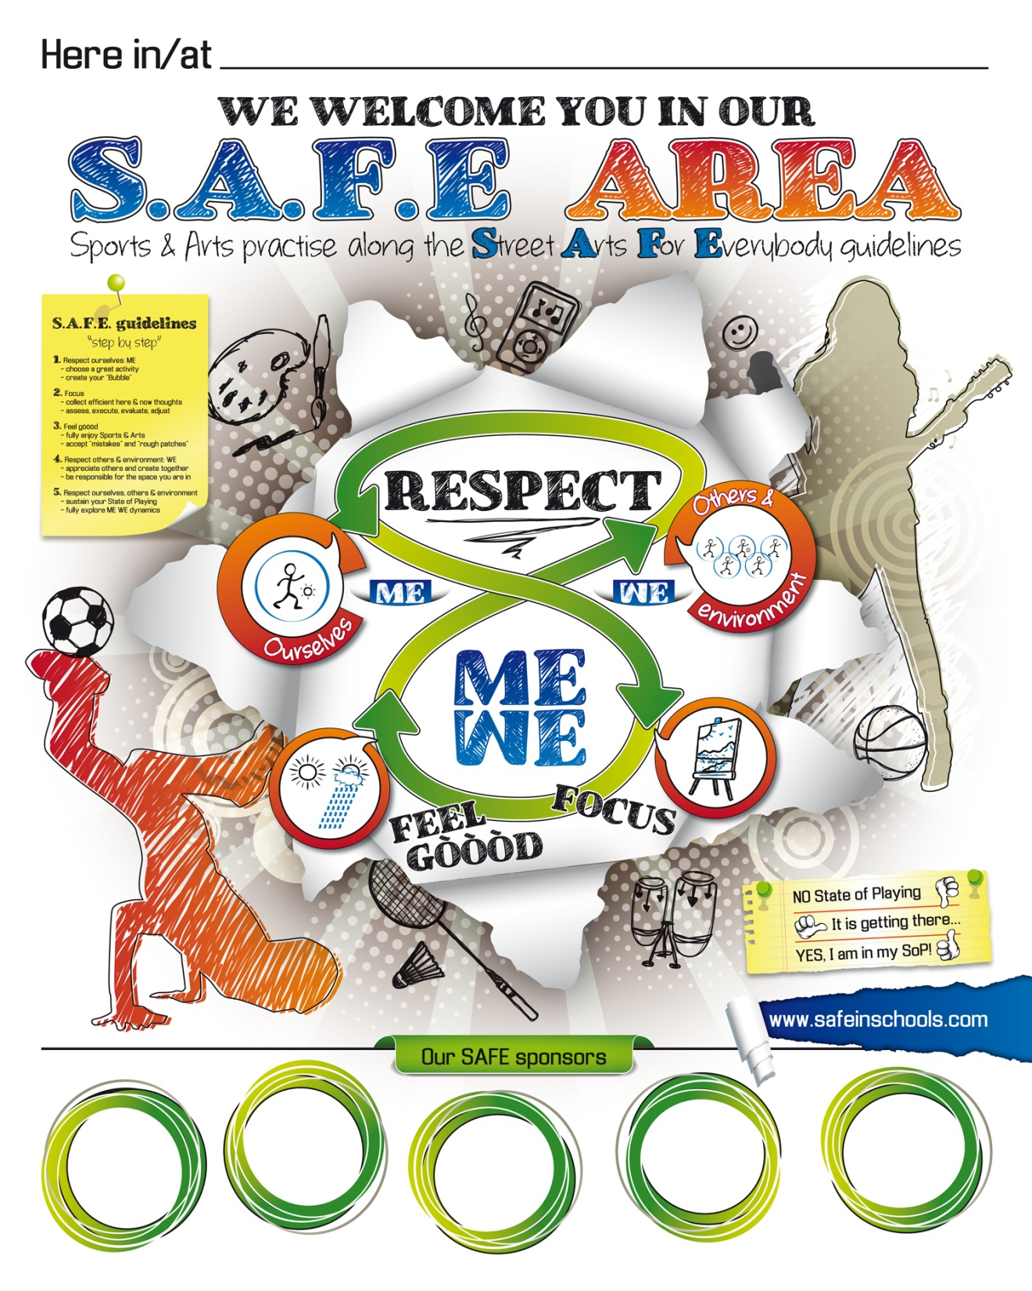

Welcome in our S.A.F.E. AREA

At the beginning of each Street Arts For Everybody session, we “warm up” three of our human functions; our capacities to Respect, to Focus and to Feel gòòòd. These three functions play a big role when we practice Sports & Arts and – like our body – they can be a little “stiff” and in need of some attention before they can fully function.

Who are your favourite athletes and artists? When you look at their careers (and those of stars from the past) you notice of course that they work (play!) really hard on developing their skills, but what all great players also have in common is that they prepare themselves well for their athletic games or artistic sessions, each time. They RESPECT themselves. And because they do they can fully FOCUS on exploring & refining their skills while often fully ENJOYING it.

This is what our SAFE AREA is all about. It is a place of RESPECT, because everyone is practising with as much FOCUS and JOY as possible. Whatever Street Art we choose to practice, each one of us “warms up” these human functions individually, whether we actually practice along the SAFE guidelines in “the streets” or at a school, club, community center or anywhere else. The SAFE AREA is a place where all players, all artists get the best out of themselves and where each session has the potential to turn into a Creative Feast.

The SAFE AREA POSTER is a guide to get us back in touch with our basic skills and to find our State of Playing. This is our state of being that allows us to truly PLAY. Whether we play music, dance, play ball or any other Street Art, when we are in our State of Playing (SoP), our instrument, body, ball or whatever tool we use “listens to us”.
Let’s play SAFE; let’s first find OUR SoP!

The SAFE guidelines, “step by step”

The quotation marks are around “step by step”, because the three human functions we “warm up” at the start of each SAFE playshop are interdependent. As soon as we pay attention to one, the others get perked up a little too. Yet “warming them up” in the following order has proven to be really efficient to find our State of Playing.

Step 1. Respecting ourselves
The list of “people & things” we interact with every day is long. Now, at the beginning of our Street Art session, we need to exclude much of that list for the time being. This is part of Respecting ourselves. Whatever role we play in society; it is important to find moments to do what we love doing and let the rest of the world be for a while.
So choose YOUR favourite Street Art (or one of them) plus a warm up exercise you are comfortable with (and don’t choose the activity and exercise, because your friend did!). Then start your exercise while you right away start creating your “Bubble”. When there are other people around, pretend they are not there for a while. Do the same with all people who are not present, but who you still “carry” (family, friends, etc.). Do the same with everything else (plans, responsibilities, worries, etc.). You are in your Bubble when everybody & everything are ”gone”. ME first…!
If you are new to this, it might take a while. If you are an experienced SAFE player, creating your Bubble can go fast.
Step 2. Focus
a) Filter your thoughts; some of them you need, many you don’t. This is easy to say, but not always easy to do! Those of you who have experience with any form of meditation… it is the same thing! At the beginning your attention for the matter at hand will try to escape and each time it does, you have to grab it back. Very important: if there is any negative self-talk going on in your head (“I am no good”, “what do others think of me”, etc); “eject” that from your mind and replace it by positive self-talk. However keep your cheer-leading thoughts short, because:
b) Once your attention is here & now, direct it full-time towards the many aspects of your Street Art. There is so much you have to focus on. Even when you practice alone, there is a list of smaller and bigger aspects to consider. You have to continuously assess your situation, execute the appropriate movements, evaluate the results and adjust your next intentions, according to the feedback you get from your instrument, body, ball or other tool. This is an ongoing process!
We symbolize our Focus by looking at a painting. Our eyes can go over various parts of the painting and zoom in on and out of many details, but they need to stay within the frame.

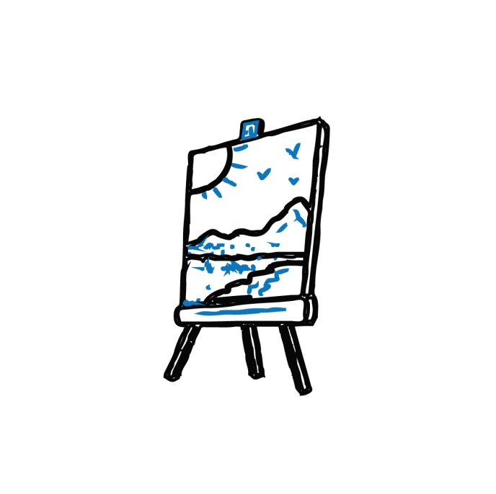

Step 3. Feel gòòòd
Relàààx. You are practicing one of your favourite Street Arts! Whatever is going on in the rest of your life, you are now taking a break from everything. It is time to play! Not only is this your birthright, but everything you do in life goes better when you play.*
By the way, with “relax” we don’t mean moving slow, but putting in “effort without effort”, even in fast movements. That smile on your face (or your “inner smile” behind your face) has a direct effect on how you do whatever you are doing. Let yourself be energized by the powerful feelings of JOY and of RESILIENCE.
a) JOY – whatever your Street Art is, once you are in your Bubble and you fully FOCUS, you will start to enjoy the many little victories in stabilizing a routine or in trying out the next steps on the endless ladder of skill development. On top of that, if you practise a Street Art regularly there will be moments you reach a smaller or bigger milestone, which will give you extra shots of joy.
b) RESILIENCE – whatever your Street Art is, you have to process the many little “mistakes” that are part of any skill development and evaluate them in order to adjust the next try. On top of that, if you practise a Street Art regularly there will be setbacks and harder challenges in need of extra shots of resilience. Stay focused and do your best. Keep on feeling the sun behind the clouds!

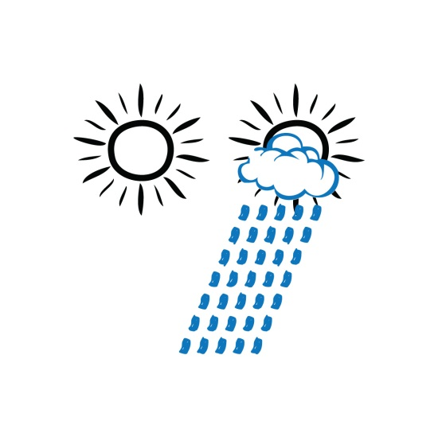

*If you explain this to adults and they don’t believe you, tell them to visit www.nifplay.com

Step 4. Respecting others & our environment
a) RESPECTING OTHERS – after you have spend some time practicing in your Bubble, with a strong FOCUS while FEELING GÒÒÒD, you almost always find your State of Playing. Thumb up: YES, I am in my SoP! It is time to team up with others or keep on creating alone while at the same time connecting with what others are doing. Now we are truly able to appreciate the skills of others, learn from each other and play or create together: WE…!
b) RESPECTING OUR ENVIRONMENT – more & more people express their concerns for the Environment at large. However truly caring for it starts with experiencing the influence our immediate environment has on us. And the best place to notice these often subtle influences is when we are in full creation… or not…! The many physical and environmental facets of our Street Arts (the material we use, the space we practise in, the quality of the light around us, the air we breathe, etc.) are a vital part of the multifaceted assessing, executing, evaluating and adjusting process of SAFE players.
Once you are in your SoP and able to consider all physical and environmental aspects, being responsible for the material and for your immediate environment is part of your game.
Step 5. Respect ourselves, others & our environment
When we fully respect others & our environment, we fully respect ourselves. We come full circle, or better; full 8. The challenge you face now is to sustain your SoP while you engage in the group activity. Often players lose their ME SoP when they join the group or team. Once you develop the skill of sustaining your SoP in the group, you can thrive on the ME WE dynamics and enjoy many creative peaks. The movement of the 8 can go on & on.
How long does it take to find my State of Playing?
The time it takes to reach our State of Playing (SoP) is different for every person, every day. It doesn’t have to be long if we have practiced the day before. It often takes longer if it has been a while. However there are no rules here.
In Street Arts we have a fantastic, 100% accurate source of feedback that lets us know exactly where we are at: our instrument, body, ball or whatever our tool is. When we just start our session and we are still in “daily life mode”, our tool often does “its own thing”. Then, when we gradually find our SoP it starts to listen to us more & more. When we get more experienced in using the SAFE guidelines this will go faster.
This is always a very personal experience. You are the only one that can truly sense whether you are in your SoP or not. One indicator might be that you have stabilized your basic skills and now start to nail some harder skills (at whatever level you are). But there is another important indicator every SAFE player needs to learn to identify. Every Street Art has an (often subtle) hypnotizing and enchanting influence on players who play with RESPECT and FOCUS while FEELING GÒÒÒD. You know you are getting into your SoP when you start experiencing those wonderful moments you surprise yourself with unexpected moves or when your instrument, body, ball or other tool starts to even follow some of your intuitive intentions. You were just thinking about some possible move and you did it. Or little or bigger amazing creative happenings take place, you never thought of. Indeed, in our SoP, life becomes a little magic. Don’t be shy to share this with the Player / Facilitators around you. They are looking for these little or bigger magical moments in every session!
In the beginning of SAFE sessions we symbolize the absence of our SoP by the thumb down gesture (or thumb almost down for “not quite”). Then when we are getting closer to our SoP we show our thumb halfway. And when our instrument, body, ball or other tool is really listening to us, we can show our thumb up.
Showing these thumb gestures is optional of course. However even just thinking about them inspires us to keep on asking the key question: “where am I at?”
Using these gestures between fellow SAFE players will help you in timing when to open up to the group activities. When you are able to sustain your SoP in a group of players who also sustain their SoP’s, you can experience that “the whole is greater than the sum of its parts”. When SAFE players play & create together in their SoP’s, SAFE sessions almost always turn into a Creative Feast!
WELCOME IN OUR S.A.F.E. AREA

