S.A.F.E. AREA Manual

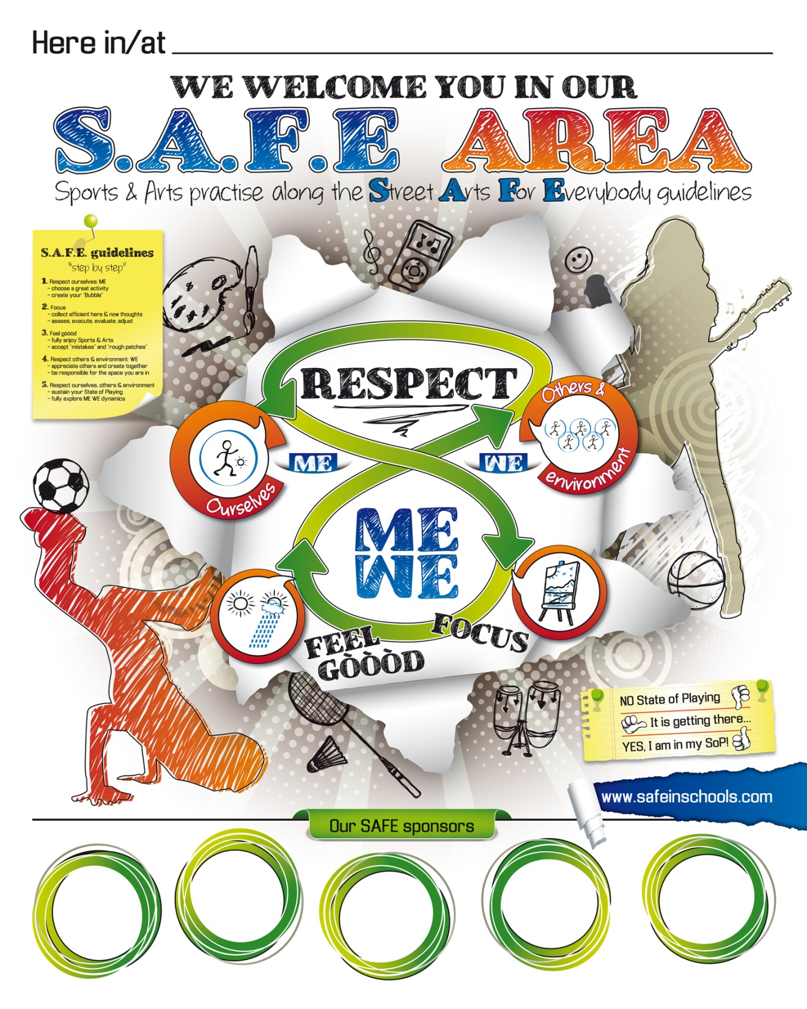

Welcome in our S.A.F.E. AREA!

It is so nice to have you with us! This manual is summarized on the SAFE AREA Poster that hopefully hangs on the wall close to where you play. If not, you can see it here on the front page. Check it out!

The Manual / Poster is a guide to find your State of Playing. Do you know this feeling, when you play music or dance, play ball or any sport, game or form of art and your instrument, body, ball or whatever device you use, “listens to you”? Everything seems to go so smooth! Well, that is when you are in your State of Playing. As you can see on the Poster, we symbolize this with ‘’THUMBS UP’’!

Unfortunately we don’t always experience this. Often when we are playing it goes OK, but not really as good as we could. Sometimes we don’t even play at all; we have a hard time and are stressed!

However, with the help of the Manual / Poster, you will be able to find your State of Playing (SoP), as often as you want...! Just follow the guidelines! The greatest athletes and artists of the world have always followed them. Whether we are beginners or advanced players, the guidelines to find our SoP always stay the same:

1. Respect yourself: find the activity(ies) you love doing and make sure you do it (them) a lot!
2. Focus: get a grip on your thinking patterns; zoom into Here & Now!
3. Feel gòòòd: fully enjoy playing / learn to accept & use ‘’mistakes’’.
4. Respect others and your environment: play together, learn from each other, in an inspiring environment and create a ME WE Feast!

So... let’s get started and first find your State of Playing!

The SAFE guidelines, “step by step”

To Respect, to Focus and to Feel gòòòd (see Poster) are human functions we often have to “warm up” at the start of each SAFE playshop. Like our body, they can be a little ‘’stiff’’ at first and in need of some attention. We put quotation marks around ‘’step by step’’; they are interdependent. As soon as we pay attention to one, the others get perked up a little too. We have found out that many players find it really efficient to “warm them up” following these steps in order to first get back in touch with their basic skills and then find their SoP.

Step 1. Respecting ourselves
The list of “people & things” we interact with every day is long. Now, at the beginning of our Street Art session, we need to exclude much of that list for the time being. This is part of Respecting ourselves. Whatever role we play in society; it is important to find moments to do what we love doing and let the rest of the world be for a while.
So choose YOUR favourite Street Art (or one of them) plus a warm up exercise you are comfortable with (and don’t choose the activity and exercise, because your friend did!). Then start your exercise while you right away start creating your “Bubble”. When there are other people around, pretend they are not there for a while. Do the same with all people who are not present, but who you still “carry” (family, friends, etc.). Do the same with everything else (plans, responsibilities, worries, etc.). You are in your Bubble when everybody & everything are ”gone”. ME first…! If you are new to this, it might take a while. If you are an experienced SAFE player, creating your Bubble can go fast.
Step 2. Focus
a) Filter your thoughts; some of them you need, many you don’t. This is easy to say, but not always easy to do! Those of you who have experience with any form of attention training (meditation, yoga, etc.); it is the same thing! At the beginning your attention for the matter at hand will try to escape and each time it does, no big deal, just grab it back. Try again; now longer! Very important: if there is any negative self-talk going on in your head (“I am no good”, “what do others think of me”, etc); “eject” that from your mind and replace it by positive self-talk. However keep your cheer-leading thoughts short, because:
b) Once your attention is here & now, direct it full-time towards the many aspects of your Street Art. There is so much you have to focus on. Even when you practice alone, there is a list of smaller and bigger aspects to consider. You have to continuously assess your situation, execute the appropriate movements, evaluate the results and adjust your next intentions, according to the feedback you get from your instrument, body, ball or other tool. This is an ongoing process!
We symbolize our Focus by looking at a painting. Our eyes can go over various parts of the painting and zoom in on and out of many details, but they need to stay within the frame.

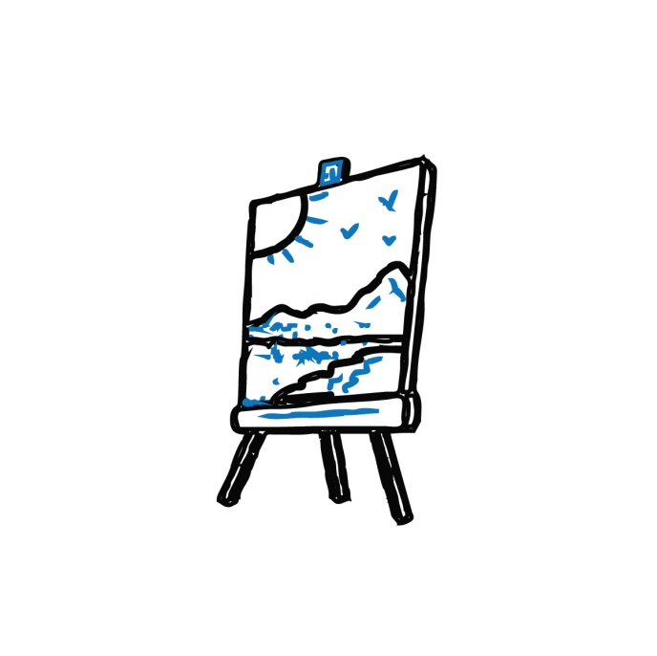

Step 3. Feel gòòòd
Relàààx. You are practicing one of your favourite Street Arts! Whatever is going on in the rest of your life, you are now taking a break from everything. It is time to play! Not only is this your birthright, but everything you do in life goes better when you play.*
By the way, with “relax” we don’t mean moving slow, but putting in “effort without effort”, even in fast movements. That smile on your face (or your “inner smile” behind your face) has a direct effect on how you do whatever you are doing. Let yourself be energized by the powerful feelings of JOY and of RESILIENCE.
a) JOY – whatever your Street Art is, once you are in your Bubble and you fully FOCUS, you will start to enjoy the many little victories in stabilizing a routine or in trying out the next steps on the endless ladder of skill development. On top of that, if you practise a Street Art regularly there will be moments you reach a smaller or bigger milestone, which will give you extra shots of joy.
b) RESILIENCE – whatever your Street Art is, you have to process the many little “mistakes” that are part of any skill development and evaluate them in order to adjust the next try. On top of that, if you practise a Street Art regularly there will be setbacks and harder challenges in need of extra shots of resilience. Stay focused; it is just a cloud. A small one or a big one, but it will pass!

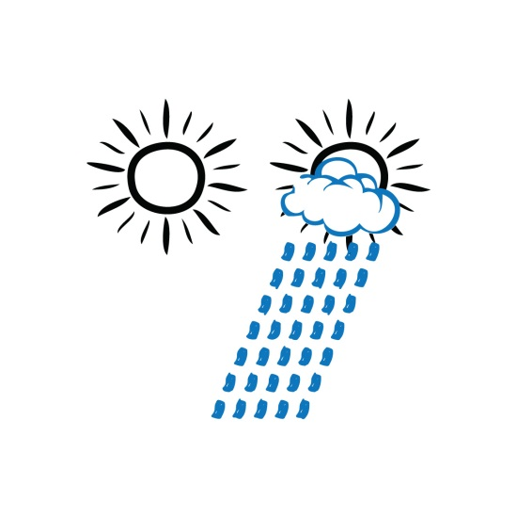

*If you explain this to adults and they don’t believe you, tell them to visit www.nifplay.com

Step 4. Respecting others & our environment
a) RESPECTING OTHERS – after we have spend some time practicing in our Bubble, with a strong FOCUS while FEELING GÒÒÒD, we almost always find our State of Playing. Thumbs up: YES, I am in my SoP! It is time to team up with others or keep on creating alone while at the same time connecting with what others are doing. Now we are truly able to appreciate everybody’s skills, learn from each other and play or create together: WE…!
b) RESPECTING OUR ENVIRONMENT – more & more people express their concerns for the environment at large. However truly caring for ‘’the planet’’ starts with experiencing the influence our immediate environment has on us. The best place to notice these often subtle influences is when we are in full creation… or not…! The many physical and environmental facets of our SAFE AREA (the material we use, the type of space we practise in, the quality of the light around us, the air we breathe, etc.) are a vital part of the never-ending assessing, executing, evaluating and adjusting process of SAFE players. This is where Art and Science meet!
Once we are in our SoP, our immediate environment becomes part of our game.
Step 5. Respect ourselves, others & our environment
When we fully respect others & our environment, we fully respect ourselves. We come full circle, or better; full 8. The challenge we face now is to sustain our SoP while we engage in group activities. Often players lose their ME SoP when they join the group or team. Once we develop the skill of sustaining our SoP in the group, we can thrive on the ME WE dynamics and enjoy golden moments (experience Flow, be in the Zone). THE SKY IS THE LIMIT!
How long does it take to find my State of Playing?
The time it takes to reach our State of Playing (SoP) is different for every person, every day. It doesn’t have to be long if we have practiced the day before. It often takes longer if it has been a while. However there are no rules here.
In Street Arts we have a fantastic, 100% accurate source of feedback that lets us know exactly where we are at: our instrument, body, ball or whatever our device is. When we just start our session and we are still in “daily life mode”, our device often does “its own thing”. Then, when we gradually find our SoP it starts to listen to us more & more. When we get more experienced in using the SAFE guidelines this will go faster and get better.
However this is always a very personal experience. You are the only one that can truly sense whether you are in your SoP or not. One indicator might be that you have stabilized your basic skills and now start to nail some harder skills (at whatever level you are). But there is another important indicator every SAFE player needs to learn to identify. Every Street Art has an (often subtle) hypnotizing and enchanting influence on players who play with RESPECT and FOCUS while FEELING GÒÒÒD. You know you are getting into your SoP when you start experiencing those wonderful moments you surprise yourself with unexpected moves and your instrument, body, ball or other tool starts to follow your intuitive intentions. You were just thinking about some possible move and you did it. Or little or bigger amazing creative happenings take place, you never thought of. Indeed, in our SoP, life becomes a little magic. Don’t be shy to share this with other SAFE players around you. This is what we live for; we are looking for these smaller or bigger magical moments in every session!
In the beginning of SAFE sessions we symbolize the absence of our SoP by the thumb down gesture (or thumb almost down for “not quite”). Then when we are getting closer to our SoP we show our thumb halfway. And when our instrument, body, ball or other tool is really listening to us, we can show our thumb up.
Showing these thumb gestures is optional of course. However even just thinking about them inspires us to keep on asking the key question: “where am I at?”
Using these gestures between fellow SAFE players will help you in timing when to open up to the group activities. When you are able to sustain your SoP in a group of players who also sustain their SoP’s, you can experience that “the whole is greater than the sum of its parts”. When SAFE players play & create together in their SoP’s, SAFE sessions always turn into a Creativity Feast!
WELCOME IN OUR S.A.F.E. AREA

